**Lesson 3 Demo 10**

**Setting up a Highly Available Cluster**



Steps to be followed:

1. Creating a highly available cluster
2. Adding CNI plugin to the cluster
3. Adding worker nodes to the cluster

**Step 1: Setting up a highly available cluster**

* 1. Type the following command to stop kubelet:

***sudo systemctl stop kubelet***

* 1. Reset the cluster by typing the following command:

***sudo*** ***kubeadm reset***

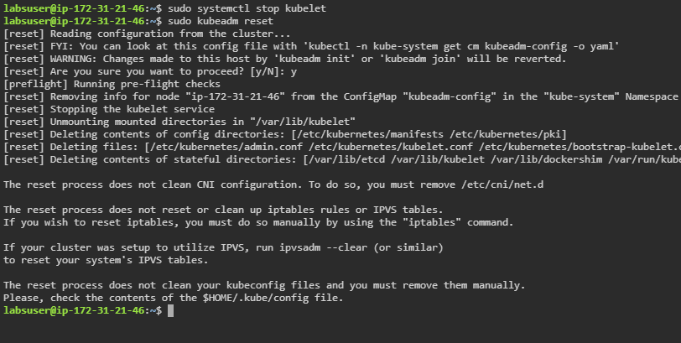



* 1. Repeat **Step 1.2** on **worker1** and **worker2** nodes to reset kubeadm on worker nodes

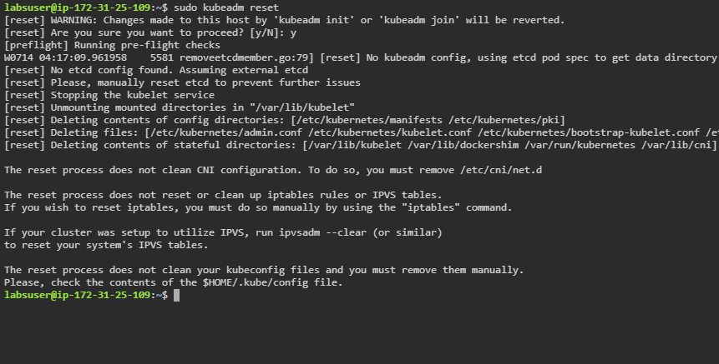

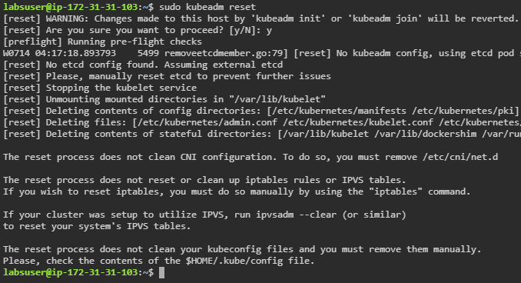

* 1. On the master node, type the following command to remove the etcd folder:

***sudo rm -r /var/lib/etcd***

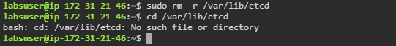

* 1. Type the following to create a highly available cluster:

***sudo kubeadm init --control-plane-endpoint 172.31.21.46 \***

***--pod-network-cidr=192.168.0.0/16***

| **Note:** Replace **<<IP Address>>** with the ip address of your master node. |
| --- |

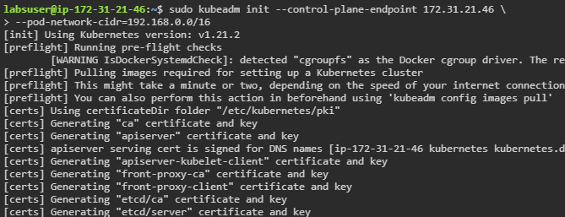

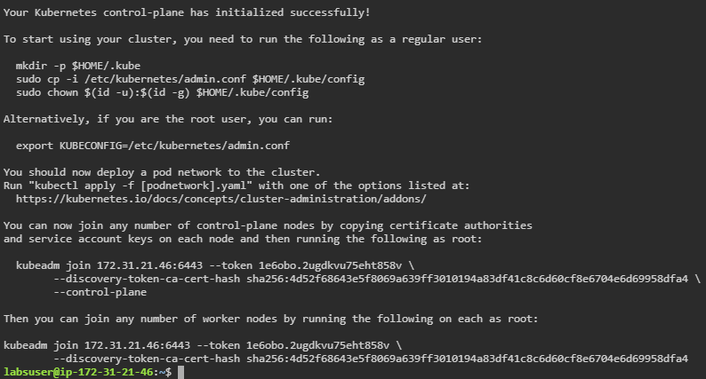

* 1. Use the following commands to give root access to kube config:

***mkdir -p $HOME/.kube***

***sudo cp -i /etc/kubernetes/admin.conf $HOME/.kube/config***

***sudo chown $(id -u):$(id -g) $HOME/.kube/config***

**Step 2: Adding CNI plugin to the cluster**

| **Note:** Follow **Step 1.4** of **Lesson 3 Demo 1** if you want to add the Calico CNI plugin. |
| --- |

1. Use the following command to add Weave Net CNI plugin:

***kubectl apply -f "https://cloud.weave.works/k8s/net?k8s-version\***

***=$(kubectl version | base64 |tr -d '\n')"***

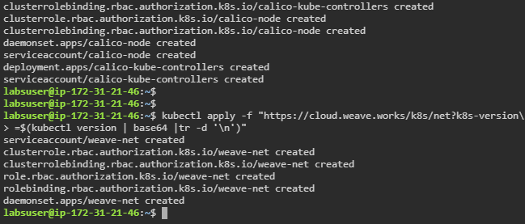

**Step 3: Adding worker nodes to the cluster**

| **Note:** Follow **Step 2** and **Step 3** of **Lesson 3 Demo 1** to add worker nodes to the cluster and verify them. |
| --- |